SAVANAH WOMEN FARMERS ASSOCIATION (SWFA)
A report by Alhassan Musah (Project Officer)
A report on the Field Visit to Project Site at Kobilimahagu Community
As part of deliverables of the forestry and farm facility project to upscale and provide solar power borehole water system for all year round. Project team has visited the proposed project site to study the local conditions and the nature of the soil and types of crops suitable to grow in Kobilimahagu Community.
Stakeholders’ engagement
The project team engaged community members, the chief and elders and Women groups secretary and discussed project execution and benefits the project would bring to the community. About 10 hectares of land have been secured for the agroforestry. The team with community members undertook a transect walk and identified the available assets and local conditions in the community.
Borehole rehabilitation will soon commence with expert to examine the yield available in the hole for onward development. The proximity of the farm land to the home would help regular visit and farm management.
Below was borehole farm land identified for Irrigation system development?
Women groups’ secretary led project team to Chief palace to introduce the project plan to them and the benefits the project would be brought to the community. The team outline areas the project would be targeted as all year round farming activities.
Figure 1 Community entry at Chief palace in Koblimahagu project community
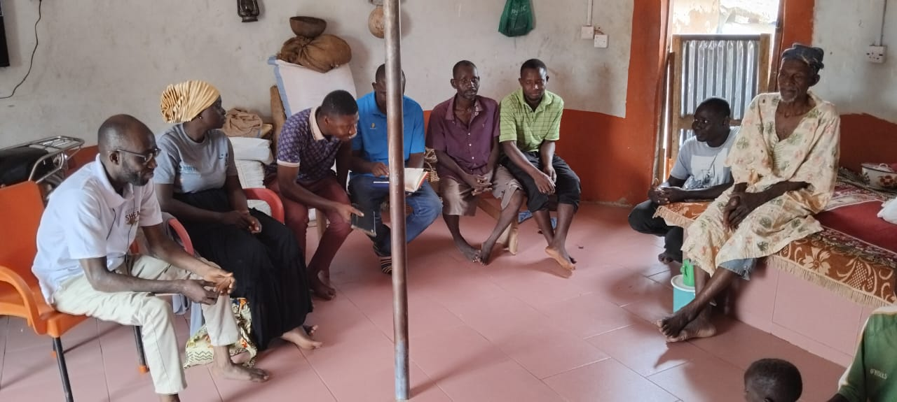
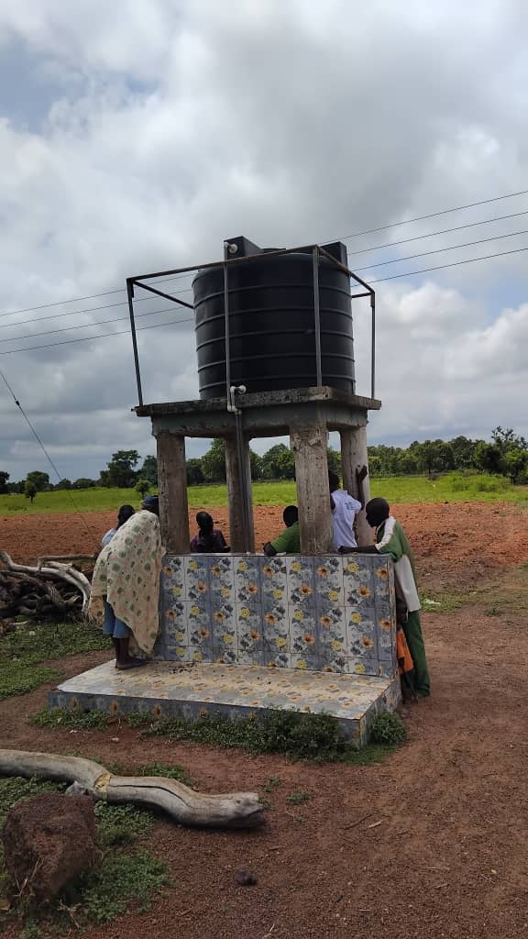
Figure 1Stakeholders assessing the borehole facility in the kobilimahugu community
Stakeholders identified borehole community released for irrigation purposed and informed the team about availability of water, but project team yet to conduct yield test on the borehole efficasy.
Conclusion:
The project team conducted community entry in order to kick- start the project implementation phase. The team and members conducted transect walk of the community and project area of implementation to identify local conditions, assets and fertile land for subsequent planning.
Stakeholders also identified borehole potential for irrigation system facility improvement with common consensus to rehabilitate the borehore for effective and efficient utilization to achieve the goal of all year round farming activities.

